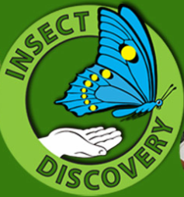
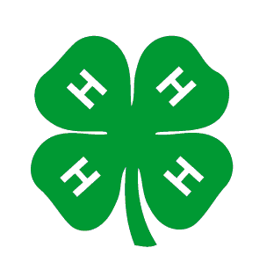

Background: Many plants require animal pollinators to transfer pollen from one plant to another for fertilization and reproduction to occur. The goal of this lesson is for students to understand the process of pollination and the importance of pollination for ecosystems as well as humans. In particular this lesson will focus on bees as pollinators. Arizona is a bee diversity hot spot and home to some 1,300 species of native bees. Most students will be familiar with the social honeybees we use in agricultural, although these are actually an introduced species, indigenous to Eurasia.
Grade level: 1-3
Academic Standards:
Time: 45 minutes
Logistics: Whole class activity at the beginning and then break the class into small groups if needed for the matching game
Materials:
“Why do bees sting?” video from Insect Discovery website
- Construction paper, cut into circles
- Glue sticks
-Markers (if desired)
- Pompoms (need multiple colors)
-Tupperware or basket or something similar
- Honeysticks or other small candy
-Matching game cards

Preparation: Cut out construction paper of various colors into circles. Make some smaller circles to be the center of the flower and many large circles to be the flower petals. Queue video “Why do bees sting?” from Insect Discovery website: https://extension.arizona.edu/arizona-insect-videos

DO - Activity:
1.) Setting the stage Ask the students what they know about bees. Is anyone scared of bees? Show the bee video. Afterwards ask the students what they learned. Should we be scared of bees? Why are bees good for our ecosystem and for us?
2.) Pollination Game First, have each student make a flower. They can choose whatever colors they want for their flowers and glue the petals together. They can also further decorate their flowers with markers. Next, explain that the students are a colony of bees. Move all students to one side of the classroom with an empty basket or Tupperware, which represents the hive. Lay out all the flowers on the other side of the room. Put a few pom poms into the center of each flower. Put all the same color pompoms in each flower. Explain to the students that these pompoms are the flower pollen and that their goal as worker bees is to collect pollen to bring back to the hive. For the first two rounds, have the students run across the room to find their own flowers and bring back pollen to the hive. They can only hold one piece of pollen at a time. For the next two rounds, tell students to visit their flower first but then they can visit any other flowers that they want. The only rule is that they can only carry one pollen (pompom) at a time. So, if they visit another flower, they have to drop off the one they are carrying and pick up a new pompom. Encourage the students to “buzz” as they fly around visiting flowers!
REFLECT
After a few rounds of pollen collecting gather the students back together to look at the results. First, look at the basket/Tupperware of pollen (pompoms). Tell the students they did a good job as worker bees gathering pollen from flowers. Ask them to remind you why bees collect pollen and why it is good for the colony. If needed remind them that this is used for food for feeding themselves and other members of the colony (like the babies!). Pollen can be turned to honey. Since they did such a great job give them some honeysticks (or other candy to enjoy). While they are enjoying the treat have them observe the flowers. Remind them that each of their flowers started with a single color of pompom. What do they see now? (At least some of the flowers should have multiple colors). Explain that this is good for the flowers because they need pollen from other flowers to continue their life cycle.
So, bees are not only collecting food for themselves, but they are also helping the flowers. They are also helping us. Ask students to give you examples of how bees help us (pollinating many of our agricultural plants, maxing wax, making honey).

APPLY
Now, tell the students that bees are not the only insects that pollinate plants. Ask if they know of any other insects that might act as pollinators (hint: what other insects do you see visiting flowers?) Tell students that this game will help them explore other types of insect pollinators.
Matching game Give each group a set of cards. Set out the cards face down in a grid. Let each student (or pair of students if playing in teams) take turns flipping over two cards at a time. The goal is to flip over an insect and the plant it pollinates. If a student/team flips over a matching pair, they keep the cards and get a point. Play until all cards are matched and count to see who wins. After the game ask students to reflect on how many different types of pollinators there are and how many plants rely on them.

